Project Structure
The diagram below shows the project folders only, from the main folder down to the lowest subdirectories.
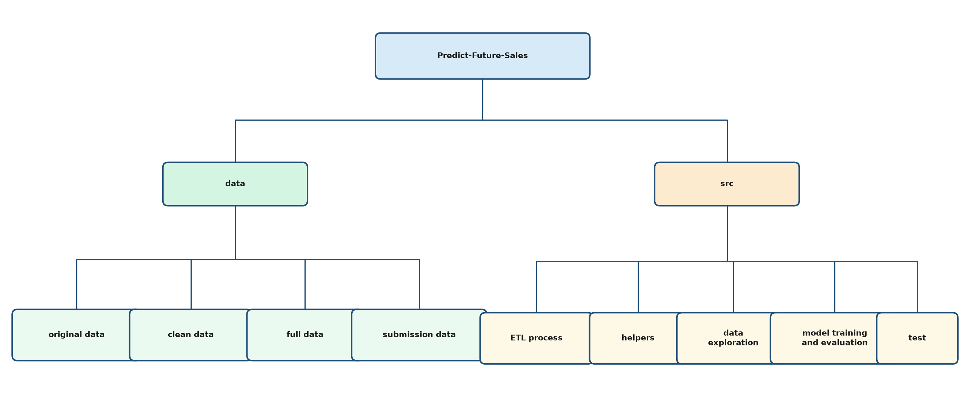
Folder and File Details
Files in the main project folder:
.env: Local settings for database login and folder paths. Keep this file private.
.env.example: A blank copy of the setting names in .env so others can fill in their own paths and credentials.
README.md: Short project overview: the Kaggle task, the data, and the tools used.
requirements.txt: List of Python packages and versions needed to run the project.
data
Stores all project datasets, from the original Kaggle files to cleaned training tables and submission files.
original data: The raw files downloaded from the competition.
clean data: Monthly shop-and-item tables ready for model training.
full data: Sales data with extra columns kept for exploration or a database.
submission data: Tables used to make and save Kaggle predictions.
original data
Unchanged competition files used as the starting point for cleaning and modeling.
sales_train.csv: Daily sales history: date, shop, item, price, and units sold.
test.csv: Shop and item pairs to predict, each with a Kaggle ID.
sample_submission.csv: Example upload file with ID and item_cnt_month.
items.csv: Item ID, item name, and category ID.
item_categories.csv: Category ID and category name.
shops.csv: Shop ID and shop name.
clean data
Training tables with one row per shop, item, and month. Daily counts are summed and price is stored as a monthly median.
sales_train_cnt_{fill method}.csv: Contains clean and aggregated data for training machine learning models with negative values replaced using the fill method.
full data
A fuller sales table used when more original columns are needed.
sales_full_0.csv: Sales data with negative counts set to 0, monthly totals added, and item category joined in.
submission data
Files for scoring the next month (month 34) and for uploading predictions to Kaggle.
{name}_submission.csv: A table of features for test shop and item pairs, or a Kaggle file with ID and predicted item_cnt_month.
src
All project code: cleaning, helpers, notebooks, and tests.
ETL process: Scripts that extract, clean, and save data.
helpers: Shared Python functions used by notebooks and tests.
data exploration: Notebooks for checking and exploring the data.
model training and evaluation: Notebooks for training models and building submissions.
test: Automated tests for preprocessing helpers.
ETL process
This folder contains code meant to extract, clean and transform original data from the competition into data for training models and store data into SQL databases or CSV format for training.
data_transform.py: Loads original CSVs and builds cleaned monthly sales tables.
load_to_csv.py: Runs the cleaning steps and writes CSV files into the data folders.
table_creation.sql: Creates the database and tables for shops, items, test IDs, and sales.
helpers
Reusable code for constants, preprocessing, features, plots, and writing submissions.
__init__.py: Shared names: feature lists, random seed, and the target column.
data_preprocessor.py: Cleans IDs, splits data, and adds features such as prior sales and prices.
feature_eng_helpers.py: Applies preprocessing, adds features, and reports which features matter.
epa_helpers.py: Summaries and plots used while exploring the data.
submission_write.py: Matches predictions to test IDs and saves a Kaggle CSV.
data exploration
Notebooks used to understand the data before building models.
data_exploration_and_validation.ipynb: Checks columns, missing values, and invalid prices or counts.
exploratory_data_analysis.ipynb: Charts and summaries of sales, shops, items, and prices.
model training and evaluation
Notebooks for comparing models, training a final model, and preparing the submission file.
model_evaluation.ipynb: Trains several models and compares their error (RMSE).
final_model_train.ipynb: Trains the chosen model and predicts sales for the test month.
submission_prep.ipynb: Builds the feature table used to score test shop and item pairs.
test
Pytest files that check the preprocessor and aggregation helpers.
conftest.py: Shared sample data and setup used by the tests.
test_aggregations.py: Checks that feature columns are calculated as intended.
test_get_top_vals_by_col.py: Checks which shop and item IDs count as the most common.
test_replace_infrequent_values.py: Checks that rare IDs are replaced with "other".
test_replace_vals_by_col.py: Checks replacing uncommon values in a single column.

